**DECLARATION**

I hereby declare that the work presented in this report entitled “**Shopping Website for T-House**", was carried out by me. I have not submitted the matter embodied in this report for the award of any other degree or diploma of any other University or Institute.

I affirm that no portion of my work is plagiarized, and the experiments and results reported in the report are not manipulated.

Name : **Tushar Gautam**

Univ. Roll No. : **0304233**

Course : **Bachelor of Computer Application**

**(Student Signature)**

**CERTIFICATE**

Certified that **Tushar Gautam (**Univ. Roll No: **0304233**) has carried out the project work presented in this report entitled “Shopping website for T-House” for the award of Bachelor of Computer Application from CSJM University, Kanpur under our guidance. The project embodies results of original work and studies carried out by the student himself and the contents of the report do not form the basis for the award of any other degree to the candidate or to anybody else from this or any other University/Institution.

|  |  |
| --- | --- |
| **Ramesh Srivastava**  Asst Professor & HOD  *Dr Virendra Swarup Institute of Computer Studies, Kanpur* | **Amit Yadav**  Asst Professor  *Dr Virendra Swarup Institute of Computer Studies, Kanpur* |

**Date:**

**Shopping website for T-House**

(Tushar Gautam)

**ABSTRACT**

T-House is a robust and user-friendly e-commerce web application that caters to the growing demand for high-quality treats with an extensive product range and a seamless online shopping experience, T-House aims to delight customers with a diverse assortment of gastronomic delights. This abstract provides an overview of the key features and benefits of the T-House web app.

Comprehensive Product Selection: T-House offers an extensive range of premium tea and coffee blends sourced from renowned estates worldwide. In addition, customers can indulge in mouthwatering burgers, sandwiches, cold coffee beverages, and delectable pizzas. The Website offer a good range of treats to buy.

User-Friendly Interface: The web app boasts an intuitive and visually appealing interface, ensuring a seamless browsing and shopping experience. Customers can T-House make purchases with just a few clicks.

Secure Payment Processing: The web app prioritizes customer data protection by utilizing secure payment gateways, allowing users to make transactions with peace of mind. Various payment options are available, including credit cards, debit cards, and digital wallets, ensuring convenience for all the customers.

Customer Reviews and Ratings: To facilitate informed decision-making, T-House incorporates customer reviews and ratings for each product. This feature enables customers to evaluate the quality and taste of the items based on real experiences, fostering a community of trust and engagement.

**ACKNOWLEDGEMENT**

First and foremost, I would like to thank our Project guide **Mr Amit Yadav** who guided us in doing these projects. He provided us with invaluable advice and helped us in difficult periods. His motivation and help contributed tremendously to the successful completion of the project.

Besides, we would like to thank **Mr** **Ramesh Srivastava**, HOD and all the teachers who helped us by giving us advice and providing the resources which we needed.

At last, but not in least, we would like to thank everyone who helped and motivated us to work on this project.

**Tushar Gautam**

*BCA Student*

*Chhatrapati Shahu Ji Maharaj University, Kanpur,*

*U.P, INDIA*

**TABLE OF CONTENTS**

**Certificate** ………………………………………….………………………………..….1

**Acknowledgements**…………………………….……………………………..……..….2

**Abstract**……………………………………………………………………………..…..3

**1. INTRODUCTION……………………………………………………………..…8-14**

1.1. Background

1.2. Motivation

1.3. Limitations of Existing System

1.4. Aim of the Project

1.5. Objectives

1.6. Methods Used

**2. PRELIMINARY……………………………………………………………...…15-22**

2.1. Introduction and Related Concepts

2.1.1. Client Side (Frontend)

2.1.2. Server Side (Backend)

2.1.3. Frontend and Backend Working Principal

2.2. Libraries and Tools Used (Dependencies)

2.2.1 Frontend Dependencies

2.2.2 Backend Dependencies

**3. PROJECT CATEGORY………………………….…………………….…...…23-23**

**4. PROPOSED WORK AND ANALYSIS……………………………..….……..24-28**

4.1. Proposed Work

4.2. Entity-Relationship Diagram

4.3. Data Flow Diagram (DFD)

4.3.1 Level-0 DFD

4.3.2 Level-1 DFD

**5. COMPLETE STRUCTURE OF THE PROGRAM…………………….……29-36**

5.1. Module Description

5.1.1. System Design Modules

5.1.2. Supporting Modules

5.2. Data Structures used in the Project

5.3. Database Management using mongoDB

5.3.1. User Schema

5.3.2. Order Schema

5.3.3. Product Schema

**6. REQUIREMENT SPECIFICATIONS………………………………………..37-42**

6.1. Functional Requirements

6.2. Operational Requirements

6.3. System Requirements

6.3.1. Software Requirements

6.3.2. Hardware Requirements

**7. PROJECT RESULTS AND SNAPSHOTS…………………………………....43-75**

7.1. Integration of Frontend and Backend

7.2. Implementation of Code

7.2.1. Frontend

7.2.2. Backend

7.3. Final Snapshots

**8. SECURITY MECHANISM……………………………………………………76-77**

**9. CONCLUSION AND FUTURE SCOPE……………………………………...78-79**

9.1 Conclusion

9.2 Future Scope

**10. REFERENCES………………………………………………………………........80**

**11. CURRICULUM VITAE.…………………………………………………………81**

**1. INTRODUCTION**

Welcome to the enchanting world of T-House, an exceptional e-commerce app that invites you to embark on a delightful journey of flavors, aromas, and traditions. As passionate tea enthusiasts, we have curated an exquisite collection of teas from around the globe, showcasing the rich diversity and remarkable craftsmanship of this beloved beverage. Step into our virtual T-House and prepare to immerse yourself in a world of serenity and indulgence.

At T-House, we believe that tea is not just a beverage but an experience to be savored and shared. Our app brings the art of tea appreciation to your fingertips, offering a wide selection of premium loose-leaf teas, tea bags, herbal infusions, and tea accessories. Whether you seek the comforting warmth of a classic black tea, the rejuvenating qualities of a green tea, T-House has something to suit every palate and mood.

What sets T-House apart is our unwavering commitment to quality. We have painstakingly sourced our teas from renowned tea estates and skilled artisans who uphold centuries-old traditions, ensuring that each cup of tea delivers an exceptional sensory experience. From the pristine tea gardens nestled in misty mountains to the expert hands that pluck and process the leaves, every step in the tea-making journey is carried out with utmost care and expertise.

Navigating the T-House app is a seamless and immersive experience. Our user-friendly interface allows you to effortlessly explore different tea categories, browse detailed product descriptions, and learn about the origins and unique characteristics of each tea. Whether you are a seasoned connoisseur or a curious novice, our app provides a wealth of information to enhance your understanding and appreciation of tea.

With secure and convenient payment options and prompt delivery, T-House ensures a seamless shopping experience from start to finish. T-House is not just an e-commerce app; it is a gateway to a world of tranquility, pleasure, and connection. Join us on this extraordinary tea adventure, and let the flavors of T-House transport you to a place of serenity and bliss.

**1.1. BACKGROUND**

T-House is a cutting-edge e-commerce app that utilizes advanced technologies to create a seamless and engaging tea shopping experience for users. Built on a robust and scalable architecture, T-House combines intuitive user interfaces, secure payment gateways, and efficient order management to provide a state-of-the-art platform for tea enthusiasts. This technical introduction highlights the key technological components and features of T-House.

**Frontend Development:** The front-end of T-House is developed using modern web technologies such as HTML5, CSS3, and JavaScript frameworks like React or Angular. These frameworks provide a responsive and interactive user interface, ensuring a smooth browsing experience across devices. The front-end also incorporates captivating design elements and intuitive navigation to enhance user engagement and ease of use.

**Backend Development:** T-House's back-end is built using a scalable server-side programming language like Node.js or Python, coupled with frameworks like Express.js or Django. This architecture ensures efficient handling of user requests, data processing, and seamless integration with databases.

**Database Management:** To store and manage product catalogs, user profiles, order details, and other essential data, T-House utilizes a robust database management system MongoDB. This database ensure efficient data retrieval, data integrity, and scalability as the application grows.

**Secure Payment Processing:** T-House prioritizes the security of user transactions by integrating with trusted payment gateways such as PayPal. This gateway utilize encryption protocols and secure APIs to protect sensitive user payment information during the checkout process.

**Order Management and Fulfillment:** T-House incorporates a comprehensive order management system that handles order processing, inventory management, and shipment tracking. This system integrates with logistics partners to provide real-time updates on order status and enables efficient fulfillment, ensuring timely delivery to customers.

**1.2. MOTIVATION**

The motivation behind developing T-House was driven by a genuine love for tea, a desire to make quality teas accessible to a broader audience, and a commitment to enhancing the tea-drinking experience through convenience, education, personalization, and community engagement.

**Convenience and Accessibility:** Traditional T-Houses often require physical visits, limiting accessibility for tea lovers who may not have easy access to such establishments. T-House was developed to bridge this gap by offering a convenient online platform that allows customers to explore and purchase teas from the comfort of their own homes, regardless of their geographical location.

**Curating an Exceptional Tea Collection**: T-House sought to curate an exceptional collection of teas from around the world, showcasing the diverse flavors, aromas, and cultural aspects associated with each type of tea. The goal was to provide customers with a comprehensive selection of teas, ranging from classic favorites to rare and specialty blends, all in one centralized location.

**Elevating the Tea Experience:** T-House aimed to go beyond the mere transactional aspect of tea purchasing and create an immersive and educational experience for users. Through informative product descriptions, brewing guides, serving suggestions, and tea pairing recommendations, T-House aimed to enhance customers' understanding and appreciation of tea, elevating their overall tea-drinking experience.

**Community Engagement:** T-House aimed to foster a vibrant and engaged community of tea enthusiasts. The platform provided opportunities for customers to share their tea experiences, leave reviews and ratings, and interact with like-minded individuals. By facilitating connections and knowledge-sharing, T-House aimed to create a sense of belonging and camaraderie among tea lovers.

**1.3. LIMITATIONS OF EXISTING SYSTEM**

Traditional tea shops and physical T-Houses offer unique experiences, they also come with certain limitations. Here are some limitations associated with existing tea shows:

**Geographical Constraints:** Physical tea shows are typically limited to specific locations, which can restrict access for tea enthusiasts residing in different regions or countries. This geographical constraint can make it challenging for individuals to explore and access a diverse range of teas.

**Limited Variety:** Tea shows often have a limited selection of teas available for tasting or purchase. Due to space constraints or logistical factors, it may not be feasible for tea shows to offer an extensive range of teas, including rare or specialty blends.

**Time Restrictions:** Attending a tea show requires visitors to be physically present during the event's designated dates and times. This can be inconvenient for individuals with busy schedules or those who are unable to travel to the specific location where the tea show is being held.

**Lack of Information:** While tea shows provide an opportunity to taste teas, they may not always offer detailed information about the origin, processing methods, and unique characteristics of each tea. Visitors may miss out on valuable insights that can enhance their understanding and appreciation of the teas they encounter.

**Restricted Community Interaction:** While tea shows can create a sense of community among attendees, the physical nature of these events may limit ongoing interaction and engagement. Once the show concludes, it may be challenging for individuals to stay connected with like-minded tea enthusiasts or continue learning and sharing their tea experiences.

By recognizing these limitations, the development of T-House as an e-commerce app aims to overcome these challenges and provide a convenient, inclusive, and enriching tea shopping experience for tea enthusiasts globally.

**1.4. AIM OF THE PROJECT**

The aim of T-House is to provide tea enthusiasts with a comprehensive and immersive online platform that offers a diverse selection of high-quality teas, elevating the tea-drinking experience. The key aims of T-House can be summarized as follows:

Curating an Exceptional Tea Collection: T-House aims to curate a wide-ranging and meticulously selected collection of teas from around the world. By sourcing teas directly from renowned tea estates and skilled artisans, T-House strives to offer an exceptional assortment of teas, ranging from classic favorites to rare and specialty blends. The aim is to provide tea enthusiasts with a platform to explore and discover teas that meet their unique tastes and preferences.

Convenience and Accessibility: T-House aims to make the world of tea more accessible to everyone, regardless of their geographical location. By offering an intuitive and user-friendly e-commerce app, T-House provides tea lovers with the convenience of browsing and purchasing teas from the comfort of their own homes. The aim is to eliminate the barriers of physical distance and time constraints associated with traditional tea shopping.

Enhancing Tea Knowledge and Appreciation: T-House aims to educate and inspire tea enthusiasts by providing detailed product descriptions, brewing guides, serving suggestions, and tea pairing recommendations. By offering informative content, T-House aims to enhance users' understanding of different teas, their origins, flavor profiles, and brewing techniques. The aim is to empower customers to make informed decisions and fully appreciate the nuances of each tea.

Fostering a Tea Community: T-House aims to foster a vibrant and engaged community of tea enthusiasts. The platform provides opportunities for customers to share their tea experiences, leave reviews and ratings, and interact with like-minded individuals. By facilitating connections and knowledge-sharing, T-House aims to create a sense of belonging and camaraderie among tea lovers.

Ensuring Customer Satisfaction: T-House places a strong emphasis on customer satisfaction. By providing secure payment processing, prompt delivery, and dedicated customer support, T-House aims to ensure a seamless shopping experience for every customer. The aim is to build trust, loyalty, and long-term relationships with tea enthusiasts.

Overall, T-House aims to be the go-to destination for tea lovers, offering a convenient, educational, and personalized tea shopping experience that celebrates the art, culture, and pleasure of tea.

**1.5. OBJECTIVES**

The objective of T-House can be summarized as follows:

To provide tea enthusiasts with a convenient, immersive, and personalized online platform that offers a diverse collection of high-quality teas, enhances tea knowledge and appreciation, fosters a tea community, and ensures customer satisfaction.

The aim of T-House is to provide customers a comprehensive and immersive online platform that offers a diverse selection of high-quality snacks and treats.

**1.6. METHODS USED**

T-House incorporates various algorithms to enhance the user experience .

Here are some algorithms that may be utilized in the development of T-House:

**Content-Based Filtering:** Content-based filtering focuses on the characteristics and attributes of items. In T-House, this algorithm can analyze the properties of teas such as flavor profiles, caffeine levels, brewing techniques, and origin to recommend similar teas to users based on their preferences and previous selections.

**Natural Language Processing (NLP**): NLP algorithms can be applied in T-House to analyze and understand user-generated content such as reviews and feedback. By employing sentiment analysis and text mining techniques, T-House can gather insights from user comments to improve product recommendations and understand customer preferences.

**Search Algorithms:** T-House may employ search algorithms such as TF-IDF (Term Frequency-Inverse Document Frequency) or semantic search to enhance the search functionality within the app. These algorithms can improve the relevance and accuracy of search results, ensuring that users can find their desired teas quickly and efficiently.

It's important to note that the specific algorithms employed in T-House may vary depending on the implementation and the data available. The development team behind T-House would select and customize algorithms based on the specific goals, data, and user requirements of the application.

**2. PRELIMINARY**

**2.1. Introduction and Related Concepts**

Welcome to the world of T-House, a cutting-edge MERN (MongoDB, Express.js, React.js, Node.js) application that combines the power of modern web technologies to create a seamless and immersive tea shopping experience. T-House is a unique online platform that brings together tea enthusiasts, high-quality teas, and advanced functionalities to cater to the needs of tea lovers worldwide. In this introduction, we will explore the related concepts behind developing T-House using the MERN stack.

The MERN stack, consisting of MongoDB, Express.js, React.js, and Node.js, is a popular and powerful combination of technologies used to build robust web applications. Each component of the MERN stack plays a crucial role in the development of T-House:

MongoDB: As the "M" in the MERN stack, MongoDB is a NoSQL database that provides flexibility and scalability. In the context of T-House, MongoDB serves as the data storage solution, storing essential information such as tea catalogs, user profiles, order details, and customer interactions. MongoDB's document-oriented nature allows for efficient and dynamic data handling.

Express.js: Representing the "E" in the MERN stack, Express.js is a web application framework for Node.js. It offers a set of tools and features that simplify the development of server-side applications. Express.js is used in T-House to handle routing, middleware management, and other server-side functionalities. It facilitates smooth communication between the client-side and server-side components of the application.

React.js: Serving as the "R" in the MERN stack, React.js is a powerful JavaScript library for building user interfaces. React.js allows for the creation of reusable UI components, enabling developers to build dynamic and interactive interfaces. T-House utilizes React.js to develop the client-side of the application, providing users with a seamless and responsive user experience while browsing and interacting with the tea collection, personalized recommendations, and other features.

Node.js: Completing the MERN stack, Node.js is a runtime environment that enables server-side JavaScript execution. It allows for the development of scalable and high-performance web applications. In T-House, Node.js acts as the server-side runtime, facilitating the handling of requests, business logic implementation, and integration with databases and external APIs.

By leveraging the MERN stack, T-House benefits from a robust and scalable architecture, efficient data handling, real-time interactivity, and a rich user interface. This stack enables developers to create a seamless and engaging tea shopping experience, with features like personalized recommendations, secure payment processing, intuitive navigation, and a vibrant tea community.

In conclusion, T-House, developed as a MERN app, combines the power of MongoDB, Express.js, React.js, and Node.js to create an exceptional tea shopping platform. By leveraging these technologies, T-House offers a dynamic, scalable, and immersive online experience, connecting tea enthusiasts with a diverse range of teas, personalized recommendations, and a community of like-minded individuals passionate about the art of tea.

**2.1.1. Client Side (Frontend)**

T-House takes advantage of a powerful frontend technology stack, leveraging React.js, Redux.js, and React Bootstrap to deliver a seamless and visually appealing user interface. This combination of frameworks and libraries enhances the user experience and ensures a responsive and intuitive tea shopping platform. Let's explore the role of each component in the frontend development of T-House:

**React.js:** React.js, a JavaScript library, serves as the core framework for building the user interface of T-House. React.js enables the creation of reusable UI components, allowing developers to build complex and interactive interfaces efficiently. With React.js, T-House provides a smooth and dynamic user experience by efficiently updating and rendering components based on data changes, resulting in fast and responsive interactions.

**Redux.js:** Redux.js is a predictable state container for JavaScript applications. It manages the state of the T-House application, providing a centralized store that holds the data required by various components. Redux.js helps in maintaining a consistent application state, making it easier to manage data flow and perform actions such as adding items to the cart, updating user preferences, and handling authentication. With Redux.js, T-House ensures a reliable and scalable state management solution.

**React Bootstrap:** React Bootstrap is a UI component library that integrates Bootstrap styles and components with React.js. By utilizing React Bootstrap, T-House benefits from a wide range of pre-designed and responsive UI elements such as buttons, forms, modals, and navigation bars. This allows developers to create a visually appealing and consistent user interface without having to build each component from scratch. React Bootstrap simplifies the process of designing and styling T-House, ensuring a professional and user-friendly look and feel.

The combination of React.js, Redux.js, and React Bootstrap empowers T-House with a robust frontend architecture. React.js facilitates the efficient rendering and updating of components, Redux.js ensures consistent state management, and React Bootstrap provides a vast library of ready-to-use UI components. Together, these technologies enhance the user interface of T-House, resulting in a visually appealing, responsive, and interactive shopping experience.

**2.1.2. Server Side (Backend)**

Let's delve into the role of each component in the backend development of T-House:

Node.js: Node.js serves as the runtime environment for T-House's backend. It allows JavaScript code to be executed on the server-side, enabling efficient handling of incoming requests and seamless communication with the frontend. Node.js's event-driven, non-blocking I/O model ensures high performance and scalability, making it well-suited for building server-side applications like T-House.

**Express.js**: Express.js is a web application framework for Node.js. It simplifies the process of building robust APIs and handling HTTP requests in T-House. Express.js provides a set of intuitive and powerful features for routing, middleware management, and request/response handling. It allows developers to define endpoints, handle authentication, and perform data validation, ensuring secure and efficient communication between the client and server.

**MongoDB:** MongoDB is a NoSQL database that serves as the backend data storage solution for T-House. Its flexible document-oriented structure allows for seamless storage and retrieval of tea catalogs, user profiles, order details, and other essential data. MongoDB's scalability and performance characteristics make it ideal for handling large volumes of data efficiently. By utilizing MongoDB, T-House can provide fast and reliable data access, ensuring a seamless shopping experience.

The backend stack of Node.js, Express.js, and MongoDB enables T-House to handle various backend operations, including user authentication, data retrieval and storage, order management, and API integration. Together, these technologies provide a scalable, performant, and secure backend infrastructure for T-House.

**2.1.3. Frontend and Backend Working Principle**

Here's an overview of the backend working principle of T-House:

**Handling Requests**: When a user interacts with T-House through the frontend, such as browsing teas, adding items to the cart, or making a purchase, the frontend sends requests to the backend. These requests are received by the server built with Node.js and Express.js.

**Routing:** Express.js provides a routing mechanism to define endpoints and map incoming requests to specific functions or controllers. Each endpoint corresponds to a specific action or functionality in T-House, such as retrieving tea catalog, processing payment, or updating user preferences.

**Request Processing:** Once a request is received and routed, the backend processes the request by performing various operations. This may involve interacting with the MongoDB database to retrieve or store data, performing business logic, handling authentication and authorization, or integrating with external APIs or services.

**Database Management with MongoDB:** T-House utilizes MongoDB as the backend database to store and manage data. The backend interacts with the MongoDB database to perform operations like retrieving tea information, updating user profiles, managing orders, and storing user reviews. MongoDB's flexible document-based structure allows for efficient data storage and retrieval.

**Response Generation:** After processing the request and performing the necessary operations, the backend generates a response. This response may include data fetched from the database, success or error messages, and any additional information required by the frontend. The response is sent back to the frontend to be displayed to the user.

**Communication with the Frontend:** The backend communicates with the frontend by sending responses in the appropriate format, such as JSON. These responses contain the necessary data and status codes to inform the frontend about the success or failure of the requested operation.

**2.2 Libraries and Tools used**

**2.2.1 Backend Dependencies/Libraries**

Here is a list of the backend dependencies used in T-House:

**bcryptjs:** This dependency is used for password hashing and encryption. It provides functions to securely hash passwords, ensuring that sensitive user information remains protected.

**dotenv:** The dotenv dependency enables the use of environment variables in the T-House backend. It loads variables from a **.env** file, allowing developers to store sensitive information, such as API keys or database credentials, securely.

**express**: Express is a fast and minimalist web application framework for Node.js. It provides essential features for building the backend of T-House, including routing, middleware management, and request handling.

**express-async-handler:** This dependency simplifies error handling in asynchronous Express.js middleware and route handlers. It allows T-House to handle asynchronous operations, such as database queries or API calls, in a more concise and error-safe manner.

**jsonwebtoken**: The jsonwebtoken dependency facilitates the generation and verification of JSON web tokens (JWTs). T-House can use JWTs for user authentication and authorization, ensuring secure access to protected routes and user-specific information.

**mongoose**: Mongoose is an Object Data Modeling (ODM) library for MongoDB. It simplifies the interaction with the MongoDB database, allowing T-House to define schemas, create models, perform database operations, and handle data validation.

**2.2.2 Frontend Dependencies/Libraries**

Here is a list of the frontend dependencies used in T-House:

**@paypal/react-paypal-js:** This dependency provides integration with the PayPal payment gateway. It allows T-House to implement secure payment processing through PayPal.

**@react-google-maps/api:** The @react-google-maps/api dependency provides a React wrapper for the Google Maps JavaScript API. It enables T-House to display interactive maps and incorporate location-related features.

**@testing-library/jest-dom,** @testing-library/react, @testing-library/user-event: These dependencies are used for testing the React components in T-House. They provide utilities and functions for writing comprehensive tests.

**Axios:** Axios is a popular HTTP client library used for making API requests. T-House utilizes axios to communicate with the backend server and fetch data asynchronously.

**Bootstrap:** Bootstrap is a widely used CSS framework that provides a set of pre-designed components and styles. T-House incorporates Bootstrap for responsive and visually appealing UI elements.

**React, React-dom:** React and ReactDOM are the core dependencies for building React applications. They provide the foundation for T-House's frontend development, including component rendering and application structure.

**react-bootstrap**: The react-bootstrap dependency combines the power of React and Bootstrap, providing ready-to-use React components that adhere to Bootstrap's styling and design guidelines. It allows for the easy implementation of UI elements in T-House.

**react-google-charts:** This dependency enables the integration of interactive and customizable charts and graphs into T-House. It facilitates the visual representation of data, such as sales statistics or customer reviews.

**react-helmet-async:** The react-helmet-async dependency allows T-House to dynamically manage the document head. It provides the ability to update the page title, meta tags, and other header information based on the current state of the application.

**react-icons:** The react-icons dependency offers a vast collection of pre-built icons that can be easily incorporated into T-House's UI. It provides a wide range of options for iconography.

**react-scripts:** React-scripts is a set of scripts and configurations used by Create React App to build and run T-House. It simplifies the development and deployment processes.

**react-toastify:** The react-toastify dependency allows T-House to display toast notifications to the user. It provides customizable and responsive notification messages for various events or actions.

These frontend dependencies contribute to the functionality, design, and performance of T-House's user interface. They enhance the development process and help create an engaging and responsive tea shopping application.

**3. PROJECT CATEGORY**

T-House falls under the category of a **Product-based app.** As an ecommerce platform specializing in teas, T-House focuses on providing a wide range of tea products to its customers. It serves as a digital marketplace where tea enthusiasts can explore, discover, and purchase various types of teas, including different flavors, blends, and origins.

As a product-based app, T-House emphasizes the showcasing and selling of tangible goods, in this case, tea products. It offers a comprehensive catalog of teas, enabling users to browse through different categories, such as black tea, green tea, herbal tea, or specialty blends. Each tea product is presented with detailed descriptions, including flavor profiles, brewing instructions, and customer reviews, helping customers make informed purchasing decisions.

T-House provides an intuitive and user-friendly interface for customers to add teas to their shopping carts, manage their orders, and proceed to secure payment processing. The app focuses on delivering a seamless and convenient shopping experience, ensuring that customers can easily navigate through the tea catalog, filter and sort products, and explore related recommendations.

Additionally, T-House may include features and functionalities specific to product-based apps, such as inventory management, stock availability updates, and notifications for restocking or new arrivals. It may also provide options for customers to leave feedback, rate teas, and contribute to a community of tea enthusiasts.

By categorizing T-House as a product-based app, it highlights its core purpose of providing a platform for customers to discover, purchase, and engage with a wide range of tea products. It demonstrates the app's focus on showcasing and selling tangible goods, emphasizing the importance of product presentation, selection, and customer satisfaction.

**4. PROPOSED WORK AND ANALYSIS**

**4.1 Proposed work**

T-House proposes to provide a comprehensive online platform for tea enthusiasts, offering a wide selection of teas and related products. The main focus of T-House is to facilitate the exploration, purchase, and enjoyment of various types of teas, catering to the diverse preferences and tastes of its customers. Here are the key functions and services that T-House aims to provide:

Detailed Product Information: T-House provides detailed information for each tea product, including descriptions, flavor profiles, brewing instructions, and ingredient details. This allows customers to make informed decisions and select teas that align with their preferences.

User-Friendly Browsing and Filtering: T-House offers intuitive navigation and filtering options, enabling customers to easily browse through the tea catalog based on specific criteria such as type, flavor, caffeine content, or origin. This simplifies the search process and helps customers discover new teas suited to their tastes.

Secure Online Ordering: T-House facilitates secure online ordering, allowing customers to add teas to their shopping carts, review their selections, and proceed to a secure checkout process. It ensures the protection of customer information and provides multiple payment options for convenience.

Community Engagement: T-House aims to foster a sense of community among tea enthusiasts. It may include features such as customer reviews, ratings, and the ability to share experiences and recommendations.

Seamless Order Management: T-House provides a streamlined order management system, allowing customers to track their orders, view order history, and manage shipping and delivery preferences.

Overall, T-House strives to create a convenient and enjoyable tea shopping experience, offering an extensive range of teas, detailed product information, personalized recommendations, and a supportive community.

**4.2. Entity Relationship (E-R) Diagram**

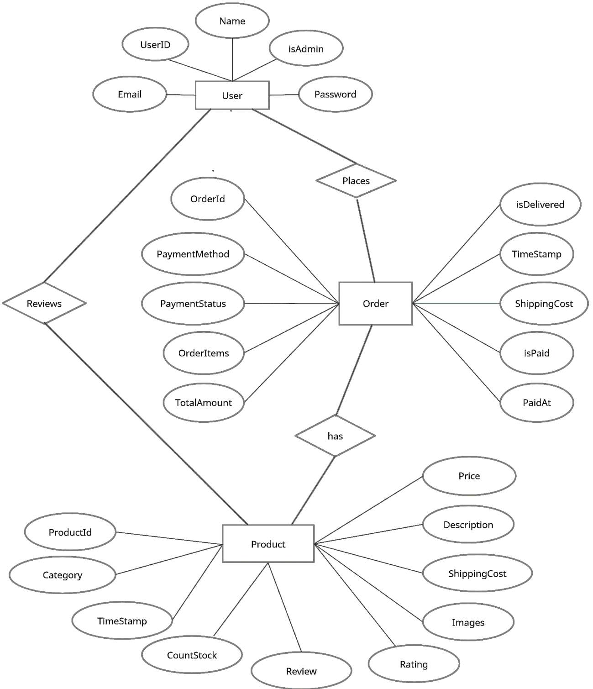

Figure. E-R Diagram for the website

**4.3 Data Flow Diagram**

A Data Flow Diagram (DFD) is a visual representation of how data flows through a system. It is a modeling technique that shows the flow of data through a system, including the inputs, outputs, and processes that transform the data.

**4.3.1. Level 0 DFD**

This 0-level data flow diagram provides a high-level overview of the key processes and interactions involved in T-House.

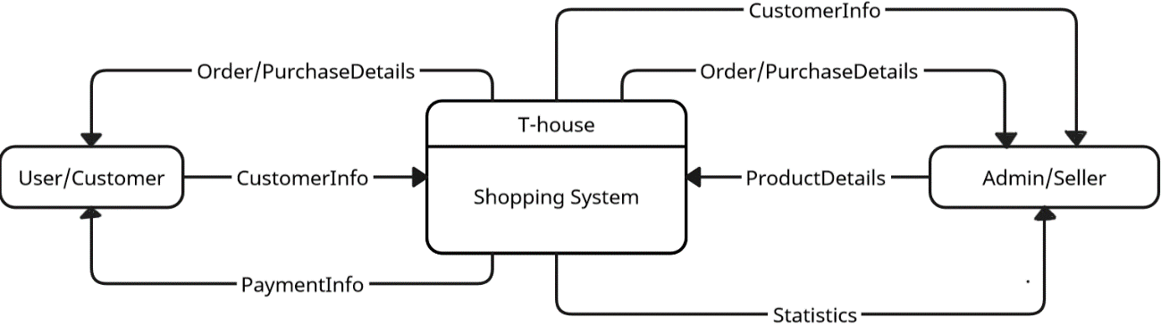

It includes the following main entities:

**User/Customer:** This entity refers to the person who will interact with the system to perform various operations such as viewing the product , creating reviews , making payments , adding products to their individual shopping cart and etc.

**Admin/Seller:** This entity keeps all the information related to the system such as user data, and the various entities .

**Shopping System:** This entity refers to T-House, which is responsible for performing various operations as per user requests.

**4.3.2. Level 1 DFD**

This level 1 data flow diagram provides a little more detailed overview of the key processes and interactions involved in the T-House Website.

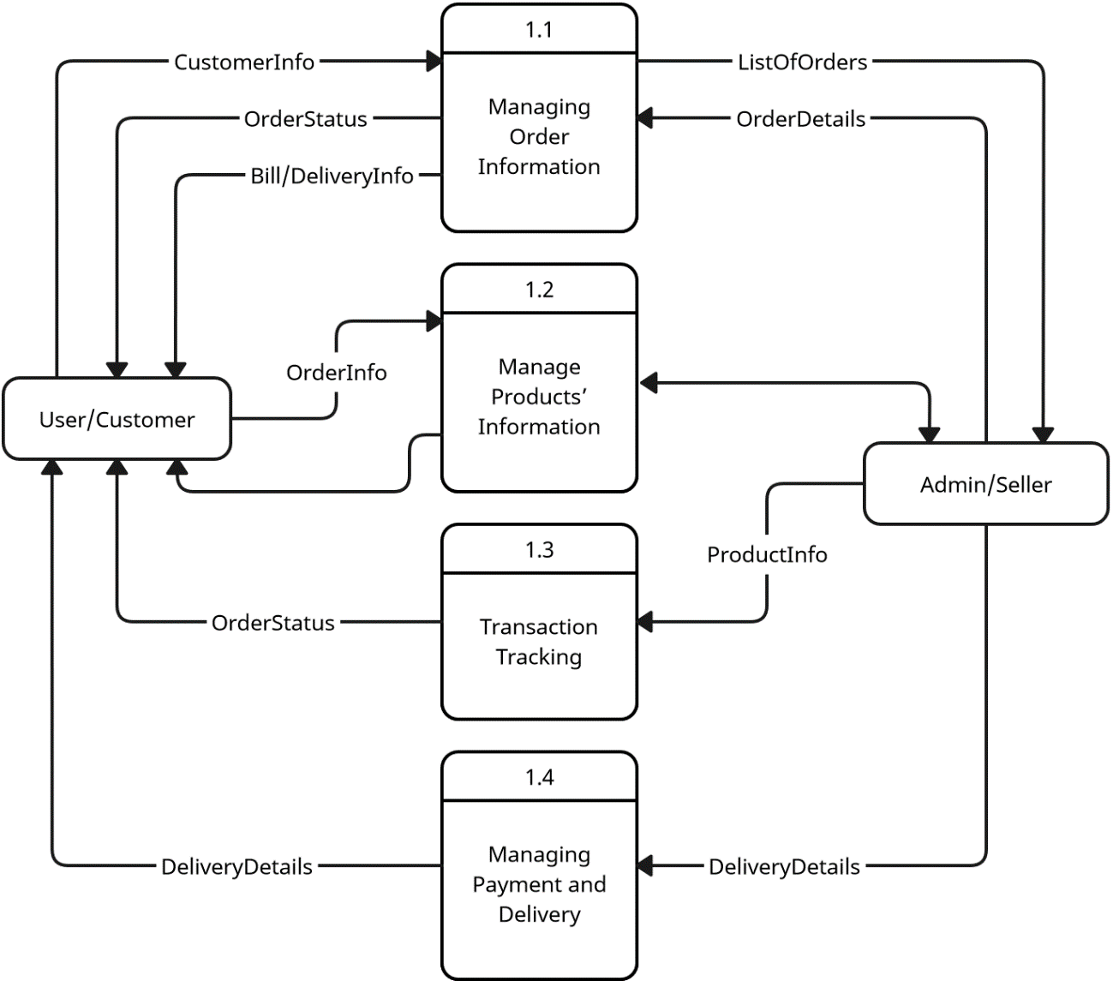

**Product Listing:** The Product Listing refers to the retrieval of data from the database and presents it to the user for browsing and selection.

**Product Details:** When the User selects a specific tea, the Tea Details component provides detailed information about the tea, including its description, flavor profile, brewing instructions, and customer reviews.

**Order Management:** The Order Management handles operations related to the shopping cart to placing an order, operations such as adding or removing teas, adjusting quantities, or applying discounts.

**Payment Processing:** The Payment Processing component interacts with the selected payment gateway to securely process the User's payment using the provided payment method.

**Order Confirmation:** After successful payment, the Order Confirmation component generates an order confirmation and sends it to the User's email address.

**Inventory Management:** The Inventory Management component keeps track of available tea stock, updating quantities when orders are placed.

**Fulfillment and Shipping:** The Fulfillment and Shipping component handles the preparation and shipping of ordered teas to the User's specified address.

**Delivery and Feedback:** The User receives the ordered teas and may provide feedback or reviews based on their experience.

**5. COMPLETE STRUCTURE OF THE PROJECT**

**5.1 Modules Description**

These backend dependencies bring in ready-made functionality, simplify development, and enhance the security, performance, and reliability of T-House. They provide essential features and tools that enable efficient server-side programming, data management, authentication, and external service integration.

**Bcryptjs:** This dependency is used for password hashing and encryption. It provides functions to securely hash passwords, ensuring that sensitive user information remains protected.

**Dotenv:** The dotenv dependency enables the use of environment variables in the T-House backend. It loads variables from a **.env** file, allowing developers to store sensitive information, such as API keys or database credentials, securely.

**Express:** Express is a fast and minimalist web application framework for Node.js. It provides essential features for building the backend of T-House, including routing, middleware management, and request handling.

**express-async-handler**: This dependency simplifies error handling in asynchronous Express.js middleware and route handlers. It allows T-House to handle asynchronous operations, such as database queries or API calls, in a more concise and error-safe manner.

**Jsonwebtoken:** The jsonwebtoken dependency facilitates the generation and verification of JSON web tokens (JWTs). T-House can use JWTs for user authentication and authorization, ensuring secure access to protected routes and user-specific information.

**Mongoose:** Mongoose is an Object Data Modeling (ODM) library for MongoDB. It simplifies the interaction with the MongoDB database, allowing T-House to define schemas, create models, perform database operations, and handle data validation.

**Streamifier**: Streamifier is a utility that converts buffers or strings into readable streams. In the context of T-House, it can be used to convert uploaded file buffers into streams for further processing or storage.

**5.1.2. Supporting Modules**

These modules/dependencies bring in ready-made functionality, design elements, and tools that enhance T-House's frontend development, user interface, interactivity, and testing capabilities. They enable developers to build a rich and dynamic user experience while optimizing development time and maintaining code quality.

**Paypal/React-Paypal-js**: This dependency provides integration with the PayPal payment gateway, enabling secure and convenient payment processing for T-House customers.

**React-Google-Maps/Api**: The @react-google-maps/api dependency allows T-House to incorporate Google Maps into the frontend. It enables features such as displaying store locations or providing interactive maps for users.

**Testing-Library/Jest-Dom**: @testing-library/react, @testing-library/user-event: These dependencies are essential for implementing unit and integration tests for T-House. They provide tools and utilities for testing React components, ensuring code reliability and preventing regressions.

**Axios**: Axios is a popular HTTP client that simplifies making API requests from the frontend. T-House may use axios to communicate with the backend API, fetching data or submitting forms asynchronously.

**Bootstrap:** Bootstrap is a CSS framework that provides pre-designed components and styles. It offers a responsive and consistent UI design for T-House, making it visually appealing and ensuring cross-browser compatibility.

**React, React-Dom**: These dependencies form the core of the T-House frontend, as React is a JavaScript library for building user interfaces. React enables the creation of reusable components, efficient rendering, and state management.

**React-Bootstrap**: React Bootstrap is a UI library that combines the power of React and Bootstrap. It provides ready-to-use components styled using Bootstrap's CSS, allowing T-House to quickly implement common UI elements and layouts.

**React-Google-Charts**: This dependency integrates Google Charts into T-House, enabling the visualization of data through various chart types. It enhances the presentation of statistical or analytical information related to teas or sales.

**React-Helmet-Async**: React Helmet Async is used to dynamically manage the document's head (title, meta tags, etc.) in React components. T-House can utilize this to dynamically set page titles and optimize search engine visibility.

**React-Icons**: React Icons is a library that provides a wide range of icons. T-House can leverage this dependency to add visually appealing icons for various actions, enhancing the overall user interface.

**React-Router-Bootstrap, React-Router-Dom**: These dependencies enable T-House to implement client-side routing and navigation within the application. They facilitate the rendering of different components based on the current URL, creating a seamless browsing experience.

**React-Scripts**: React Scripts is a set of scripts and configuration files used for the development and build process of React applications. T-House utilizes react-scripts to streamline the development workflow, enabling features like hot-reloading and optimized production builds.

**React-Toastify**: This dependency simplifies the implementation of toast notifications in T-House. It provides customizable and responsive notifications for user feedback, such as success messages or error alerts.

**Web-Vitals**: Web Vitals is a toolset for measuring and monitoring key performance metrics of web applications. T-House can utilize web-vitals to track and optimize the application's performance, ensuring a smooth and efficient user experience.

**5.2. Data Structure Used in the Project**

Various data structures are used to organize and manage data efficiently. Here are some key data structures commonly employed in the application:

Arrays: Arrays are used to store ordered collections of data, such as tea products, shopping cart items, or customer reviews. They provide fast access to elements based on their indices and are suitable for situations where the order of elements is important.

Objects: Objects are used to store and organize data as key-value pairs. In T-House, objects are employed to represent entities like tea products, user profiles, or order information. Objects allow easy retrieval of data based on specific keys and enable efficient data manipulation and retrieval.

Queues: Queues are used to manage data in a first-in, first-out (FIFO) manner. In T-House, queues might be utilized to handle customer support requests or order processing, ensuring that tasks are performed in the order they were received.

Stacks: Stacks can be employed to handle error messages or exceptions during the execution of the program. Each error message or exception is pushed onto the stack, and the program can pop and handle them in a Last-In-First-Out (LIFO) order

Dataset: The dataset is represented as a collection of names along with their corresponding labels (product names or product_ID). This dataset is typically stored in a structured format, such as a list or array.

These data structures are chosen based on the specific requirements and characteristics of the data being stored and manipulated within T-House. They provide efficient data organization, retrieval, and manipulation, facilitating smooth and optimized operations within the application.

**5.2 Tables and Collections**

The tables or the collections , describes about the various entities and field that each table/collection contains in them , here we have 3 tables and they are

**5.2.1 User Table**

The User table follows the User Schema made with Mongoose.

A Mongoose Schema defines the structure and property of the document in the MongoDB collection. This Schema is a way to define expected properties and values along with the constraints and indexes.

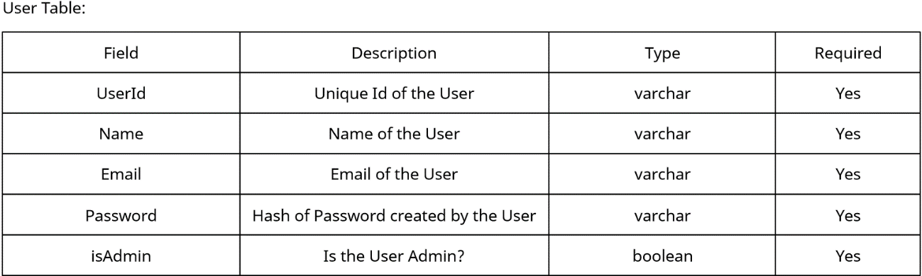

In our website, the user collection/model contains the following entities:

Name: This field represents the name of the user. It stores the user's full name or a display name that identifies them within the system.

Email: This field represents the email address of the user. It serves as a unique identifier for the user's account and is used for communication and authentication purposes.

Password: This field stores the hashed representation of the user's password. The actual password is not stored directly for security reasons. Instead, it is hashed using a secure algorithm such as bcryptjs before being stored in the database.

IsAdmin: This field is a boolean flag that indicates whether the user has administrator privileges or not. It allows the system to differentiate between regular users and administrators, granting certain privileges and access levels based on this value.

**5.2.2 Product Table**

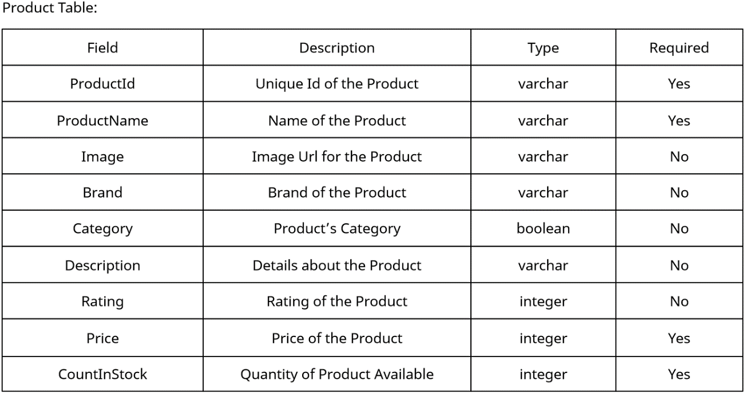

In T-House, the "product" collection/model contains the following entities:

User: This field represents the user who created or added the product. It can store the user's unique identifier or username, linking the product to the user who added it to the system.

Name: This field represents the name of the product. It stores the descriptive name or title of the product, such as the specific type or flavor of the tea.

Image: This field stores the URL or file path of the product image. It represents the visual representation of the product, allowing users to see the product's appearance.

Category: This field represents the category or type of the product. It provides a way to classify and organize products based on shared characteristics, such as "black tea," "green tea," or "herbal tea."

Review: This field stores the user's review or feedback about the product. Users can share their thoughts, opinions, or experiences related to the product in this field.

Rating: This field represents the rating or score assigned to the product by users. It provides a numerical value, typically on a scale (e.g., from 1 to 5), indicating the overall quality or satisfaction level associated with the product.

Price (type: number): This field represents the price of the product. It stores the numerical value of the product's price, allowing users to know the cost of the item.

CountInStock (type: number): This field represents the quantity of the product available in stock.

**5.2.2 Order Table**

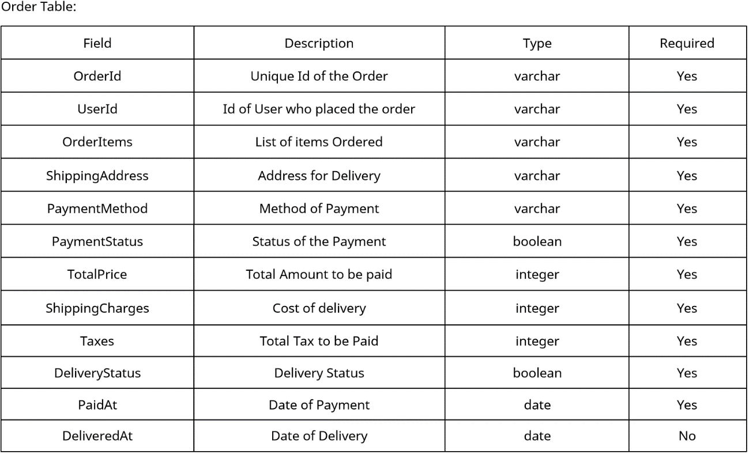

In T-House, the "order" collection/model contains the following entities:

UserId: This field represents the user who placed the order. It stores the unique identifier or username of the user, linking the order to their account.

OrderItems: This field stores the details of the items included in the order. It can contain information such as the product IDs or names, quantities, and any additional attributes associated with each item.

ShippingAddress: This field represents the shipping address provided by the user for the order. It includes the user's address information, such as street name, city, state, and postal code.

PaymentMethod: This field stores the payment method chosen by the user for the order, such as credit card, PayPal, or cash on delivery.

PaymentStatus (type: string): This field stores the result or status of the payment transaction. It can contain information such as the transaction ID, payment status, and other relevant details.

Taxes: This entity represents the price of the tax or any applicable taxes associated with the order. It stores the numerical value of the tax amount.

ShippingCharge: This field represents the price of shipping or any associated delivery charges for the order. It stores the numerical value of the shipping cost.

TotalPrice (type: number): This field represents the total price of the order, including the product prices, taxes, and shipping charges. It stores the numerical value of the total

PaidAt: This field stores the date and time when the payment for the order was made.

IsDelivered (type: boolean): This field is a boolean flag that indicates whether the order has been delivered or not. It is set to true when the order is successfully delivered to the customer.

DeliveredAt (type: date): This field stores the date and time when the order was delivered to the customer.

**6. REQUIREMENT SPECIFICATIONS**

**6.1 User Requirements**

User requirements are the needs and expectations of the end-users or stakeholders from the developed product or system. In the context of this project, the user requirements are defined as the specific needs and expectations of the users who will be interacting with T-House. These requirements include the following:

User-Friendly Interface: The application has a user-friendly interface that allows users to easily navigate and use the system without any difficulties

Secure Login: The application has a secure login system that requires the user to provide valid credentials to access the system.

Quick Response Time: The application responds quickly and efficiently to user requests.

The app should provide clear and organized product categories and filters to help users find specific products.

Users should be able to view detailed information about each product, including images, descriptions, prices, and customer reviews.

Users should be able to add products to their shopping cart.

The app should display the cart summary and update it as users add or remove items.

Users should have the ability to proceed to checkout and provide shipping and payment information.

Users should be able to choose from various payment methods, such as credit cards, PayPal, or cash on delivery.

The app should securely process and confirm the payment transaction.

Users should receive order confirmation emails with details of their purchase.

Users should have access to their order history and be able to track the status of their orders.

Users should have the ability to update their personal information, such as name, email, and shipping address.

Users should be able to change their account passwords and update their preferences.

Users should have the option to delete their accounts if desired.

Users should have the ability to leave reviews and ratings for products they have purchased.

The app should display average ratings and customer reviews for each product.

Users should be able to view and filter products based on their ratings and reviews.

**6.2 Operational Requirements**

Operational requirements for T-House outline the specific conditions, constraints, and objectives that must be met to ensure the effective and efficient operation of the web app. These requirements focus on the day-to-day functioning and management of T-House. Here are some examples of operational requirements for T-House:

System Availability:

* T-House should be accessible to users 24/7 without significant downtime or interruptions.
* The system should have a high uptime percentage, ensuring that users can access the app whenever they need to.

Performance:

* T-House should be responsive and provide a smooth user experience with minimal latency.
* The system should be capable of handling multiple user requests simultaneously without a noticeable decrease in performance.

Scalability:

* The system should be designed to handle increasing user demands and growing data volume.
* It should be scalable to accommodate a larger number of users, products, and transactions without compromising performance.

Security:

* The system should ensure secure transmission of sensitive information, such as passwords and payment details.
* Measures like encryption, secure authentication, and authorization protocols should be in place to safeguard user data.

User Management:

* The system should support user registration, authentication, and authorization.
* It should allow users to manage their profiles, update personal information, and view order history.
* User accounts should be protected from unauthorized access and data breaches.

Inventory Management:

* T-House should have a mechanism to manage product inventory, including tracking stock levels and availability.
* The system should update inventory in real-time as users make purchases, ensuring accurate product availability information.

Order Processing and Fulfillment:

* T-House should facilitate smooth order processing, including capturing orders, generating invoices, and sending order confirmation to users.
* The system should manage order fulfillment, tracking shipment status, and providing delivery updates to users.

Payment Processing:

* The system should securely process payments through various payment methods, such as credit cards, PayPal, or other online payment gateways.
* It should handle transactional data securely, ensuring the confidentiality and integrity of payment information.

Reporting and Analytics:

* T-House should generate reports and provide analytics to track sales, user engagement, and other relevant metrics.
* The system should offer insights into customer behavior, popular products, and other key performance indicators.

System Maintenance:

* The system should have provisions for routine maintenance, bug fixes, and software updates to address any issues or vulnerabilities.
* Regular backups of data should be performed to prevent data loss and facilitate system recovery.

These operational requirements ensure that T-House operates effectively and efficiently, meeting user expectations and delivering a reliable and secure platform for purchasing tea products. By fulfilling these requirements, T-House can provide a seamless user experience, streamline business operations, and maintain customer satisfaction.

**6.3. System Requirements**

System requirements are the list of hardware, software, and network components that are necessary for the proper functioning of a software system. They define the minimum and recommended specifications for the computer system and other necessary components needed to run the software. These requirements specify the operating system, processor, memory, storage, display, and other essential components that the system needs to operate. Additionally, system requirements may also include any network or security requirements needed for the software to function properly. By providing a list of system requirements, software vendors can ensure that their software will run optimally and reliably on the user's system

**6.3.1. Hardware Requirements**

A User can access our website through any device through a browser.

To run the servers and ensure good user experience, the hardware requirements are as follow:

1. Processor: At least an Intel Core i3 processor or equivalent

2. RAM: Minimum 2GB, but 8 GB or more is recommended for better performance.

3. Storage: Sufficient storage capacity , there should be about 5gb free space .

4. Operating System: The project can be implemented on any operating system, such as Windows, macOS, or Linux.

It is essential to ensure that the hardware specifications meet the minimum requirements to achieve optimal performance and avoid hardware-related bottlenecks.

**6.3.2. Software Requirements**

The software requirements for this project would typically include:

**Operating System:** The software must be compatible with the operating system used by the end-users, which in this case is usually Windows or Linux.

**Programming Language:** The project has been developed using JavaScript, HTML5, CSS, Node.js, express.js, mongoose and etc. so it is necessary to have JavaScript and node.js and mongoose installed on the system.

**Libraries:** Various JavaScript libraries have been used in the project, including. Axios , bootstrap , react-bootstrap ,react-google-chart ,react-helmet ,react-icons , react-router-dom ,react-scripts ,web-vitals and many more .These libraries must be installed and compatible with the version of Python being used.

**Integrated Development Environment (IDE):** An IDE such as Visual Studio Code may be used to develop the project..

**Database Management System (DBMS):** A DBMS is used to store product/user data images etc, , it is not mandatory for this project as the user data is stored in a simple json file.

It is essential to ensure that the software specifications meet all the requirements to achieve optimal performance and avoid software related issues in future.

**7. PROJECT SNAPSHOTS**

* 1. **Description of Frontend and Backend**

**7.1.1 Frontend**

The **frontend** of T-House is designed to provide users with an intuitive and visually appealing interface that enhances their browsing and shopping experience. Built with React.js, Redux.js, and React Bootstrap, the frontend offers a responsive and dynamic environment for users to interact with the web app.

React.js, a popular JavaScript library, enables the creation of reusable UI components that can be efficiently rendered and updated. This allows for a modular and scalable frontend architecture, making it easier to develop and maintain T-House. React.js also facilitates a smooth and seamless user interface, ensuring quick and efficient rendering of components.

To enhance the overall user experience and design consistency, React Bootstrap is utilized. It offers a collection of pre-built UI components and styles that are responsive and mobile-friendly. With React Bootstrap, T-House can achieve a visually appealing and consistent look and feel across different devices and screen sizes.

The frontend of T-House focuses on delivering a user-friendly interface that allows users to easily navigate through different sections, explore the product catalog, and add items to their shopping cart. It provides features such as search and filtering options to help users find specific products based on their preferences.

Furthermore, the frontend incorporates features like user authentication and profile management, allowing users to create accounts, update their information, and track their order history. Payment integration enables secure and convenient transactions using various payment methods.

Overall, the frontend of T-House is designed to provide an engaging and seamless user experience, combining functionality, aesthetics, and ease of use. It ensures that users can browse, select, and purchase their favorite tea products with confidence and convenience.

**7.1.2 Backend**

The backend of T-House, developed using Node.js, Express.js, and MongoDB, forms the foundation of the web application, handling data storage, retrieval, and business logic. It provides the necessary infrastructure and functionality to support the frontend and facilitate a seamless user experience.

Node.js, a JavaScript runtime environment, enables the backend to be built using JavaScript, making it a cohesive and efficient full-stack solution. It offers a non-blocking, event-driven architecture, allowing T-House to handle multiple concurrent requests efficiently. Node.js also provides a vast ecosystem of libraries and packages that enhance development productivity.

Express.js, a fast and minimalist web application framework for Node.js, provides a robust set of features for building scalable and RESTful APIs. It simplifies the process of routing HTTP requests, handling middleware, and managing server-side logic. With Express.js, T-House can easily define routes, handle authentication and authorization, and process various API endpoints.

The backend leverages MongoDB, a NoSQL database, to store and retrieve data efficiently. MongoDB's flexible document-based model allows T-House to manage complex product information, user profiles, and order details. It offers scalability and high-performance capabilities, ensuring that T-House can handle a growing user base and large amounts of data.The backend of T-House incorporates various dependencies, such as bcryptjs for password hashing, JSONWebToken for authentication, and multer for handling file uploads. These dependencies enhance the security and functionality of the web application.

The backend of T-House focuses on providing a robust and secure foundation for the web application. It handles user authentication, authorization, data storage, and retrieval, enabling the frontend to seamlessly interact with the server and access the necessary information. By utilizing Node.js, Express.js, and MongoDB, T-House ensures scalability, performance, and flexibility in managing user data and delivering a reliable and efficient e-commerce experience.

**7.2. Implementations of Code**

**7.2.1 Frontend :**

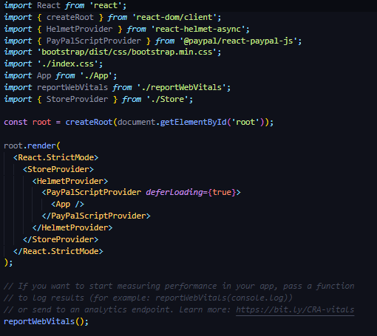

The above screen shot is index.js file

**Backend:**

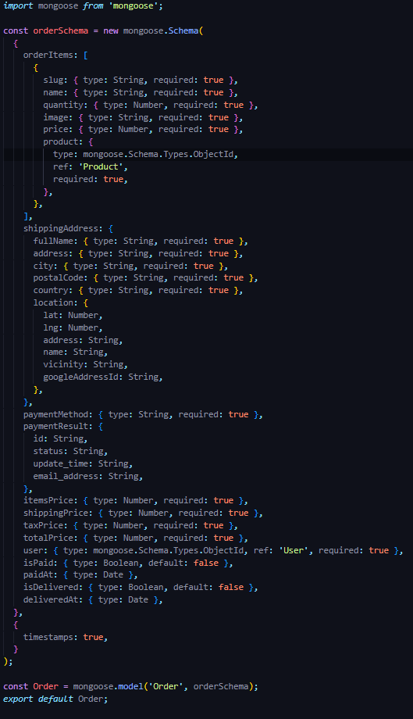

**Home page:**

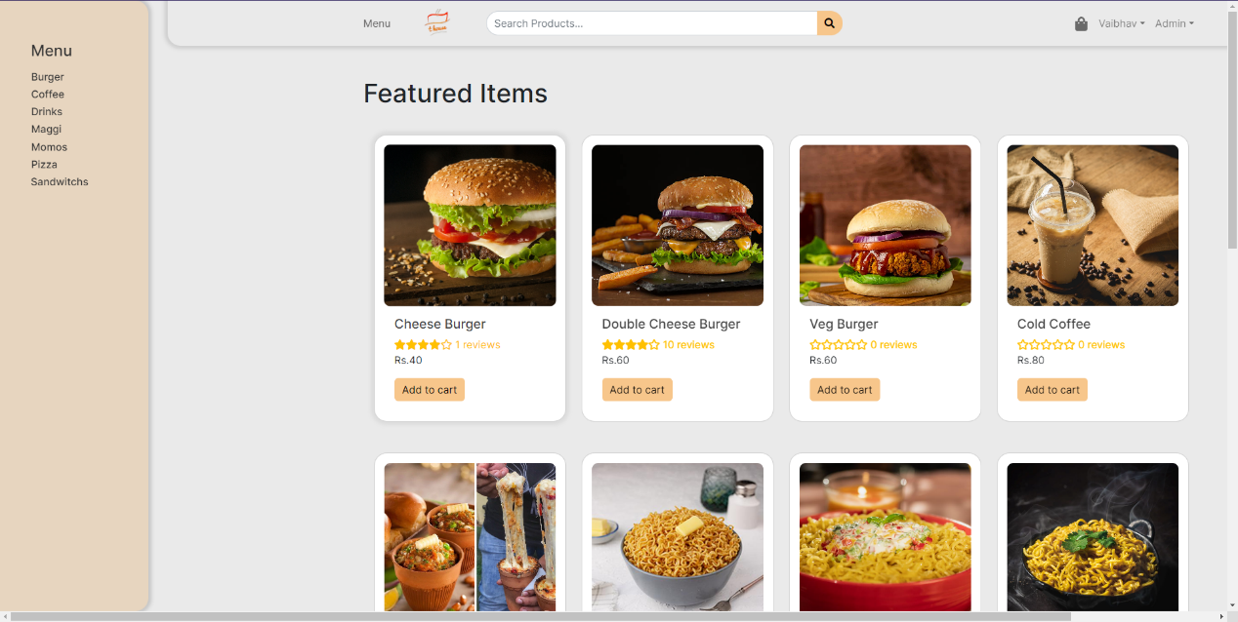

**Searching a Product:**

**Product Details:**

**Cart Screen:**

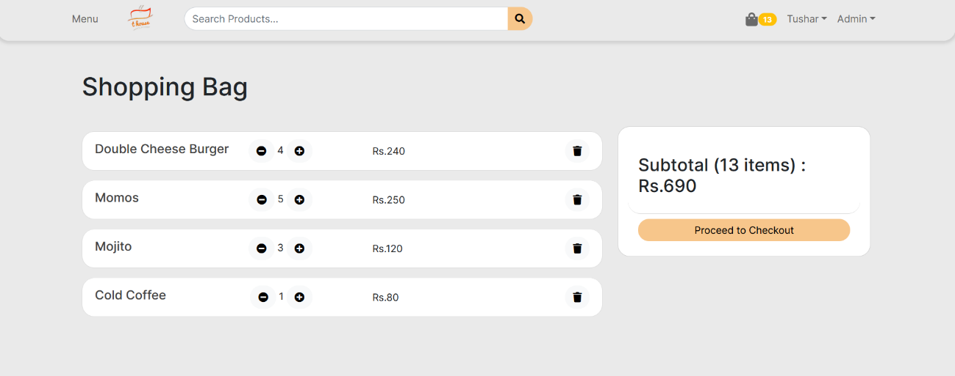

**PlaceOrder:**

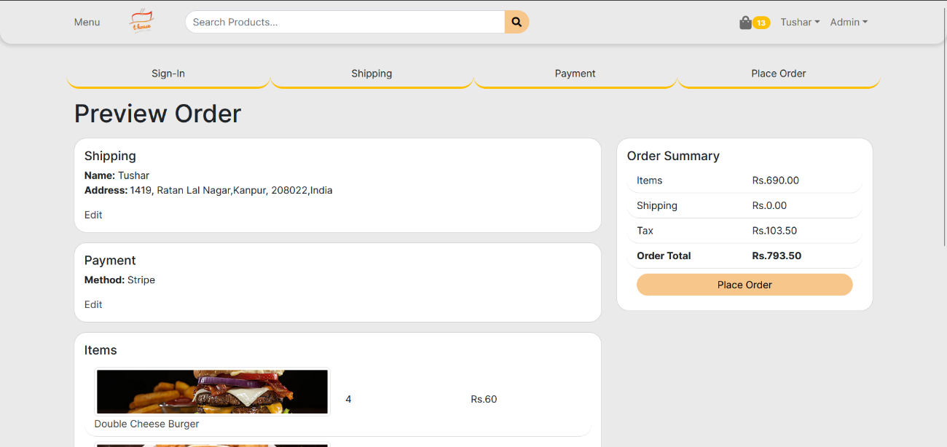

**Creating New product:**

**Creating New User**

**Admin Dashboard:**

**User List:**

**All products:**

**9. SECURITY MECHANISM**

In T-House, security mechanisms are implemented to safeguard sensitive user data, maintain the integrity of products and user records, and prevent unauthorized access. Here are some key security measures in place:

User Authentication and Authorization:

T-House employs secure user authentication mechanisms, such as bcrypt.js, to securely store and verify user passwords. This ensures that only authorized users can access their accounts.

JSON Web Tokens (JWT) are utilized for session management and authorization. When a user logs in, a unique token is generated and used to authenticate subsequent requests, protecting against unauthorized access to restricted resources.

Secure Communication:

T-House implements secure communication protocols, such as HTTPS, to encrypt data transmitted between the client and the server. This prevents eavesdropping and unauthorized interception of sensitive information.

Input Validation and Sanitization:

T-House applies strict input validation and sanitization techniques to prevent common security vulnerabilities like SQL injection and cross-site scripting (XSS) attacks. User inputs are validated and sanitized before being processed or stored in the database.

Role-Based Access Control:

T-House implements role-based access control (RBAC) to control user permissions and restrict access to certain functionalities or data. Administrators have elevated privileges, while regular users have limited access rights.

Secure Storage of Sensitive Data:

T-House ensures that sensitive user information, such as passwords and payment details, are securely stored in the database. Sensitive data is encrypted using industry-standard encryption algorithms and best practices to prevent unauthorized access.

Secure Payment Processing:

T-House integrates with trusted and secure payment gateways that comply with industry standards for secure online transactions. This protects users' payment information and ensures secure payment processing.

By implementing these security mechanisms, T-House prioritizes the protection of user data, maintains the integrity of products and records, and minimizes the risk of unauthorized access or data breaches. These measures aim to establish user trust and confidence in the security of the web application.

**10. CONCLUSION**

In conclusion, seamless and enjoyable experience for users to browse, purchase, and explore a variety of tea products. With its user-friendly interface, secure backend, and rich features, T-House aims to meet the needs of tea enthusiasts and tea lovers worldwide.

T-House has been developed using the MERN stack, incorporating MongoDB, Express.js, React.js, and Node.js, to ensure a robust and scalable architecture. The backend handles data storage, retrieval, and business logic, while the frontend delivers an intuitive and visually appealing user interface. The integration of various dependencies and libraries enhances the functionality and security of the application.

The future scope of T-House is promising, with several avenues for expansion and improvement. Some potential areas of growth and development include:

Expanded Product Range: T-House can expand its product offerings to include a wider variety of teas, tea accessories, and related products. This would cater to a broader customer base and provide more options for tea enthusiasts.

Personalized Recommendations: Implementing a recommendation engine based on user preferences and behavior can enhance the user experience. By analyzing user data and purchase history, T-House can provide personalized tea recommendations, improving customer satisfaction and driving sales.

Social Integration: Integrating social media features and user-generated content can foster a sense of community and engagement among T-House users. Users can share their favorite teas, reviews, and experiences, creating a vibrant tea-loving community.

Mobile Application: Developing a mobile application for T-House would enable users to access the platform on their smartphones and tablets, providing convenience and accessibility. This expansion to mobile platforms can attract a larger user base and increase engagement.

Advanced Analytics and Insights: Implementing advanced analytics tools can provide valuable insights into user behavior, sales trends, and inventory management. These insights can inform marketing strategies, inventory planning, and overall business decision-making.

International Expansion: T-House can explore opportunities for international expansion, reaching customers beyond its initial target market. This may involve localization efforts, language support, and adapting the platform to cater to diverse cultural preferences and preferences.

Enhanced Customer Support: Investing in customer support systems, such as live chat, chatbots, and improved helpdesk functionalities, can further enhance the customer experience. Prompt and efficient customer support can address inquiries, resolve issues, and build trust with users.

In summary, T-House has a bright future ahead with the potential to grow, innovate, and adapt to meet the evolving needs of tea enthusiasts. By embracing technological advancements, expanding product offerings, and prioritizing customer satisfaction, T-House can establish itself as a leading platform in the tea industry.

**11**. **REFERENCES**

**https://legacy.reactjs.org/**

[**https://scholar.google.com/**](https://scholar.google.com/)

[**https://legacy.reactjs.org/**](https://legacy.reactjs.org/)

[**https://redux.js.org/**](https://redux.js.org/)

[**https://mongoosejs.com/**](https://mongoosejs.com/)

[**https://nodejs.org/en/docs**](https://nodejs.org/en/docs)

[**https://expressjs.com/**](https://expressjs.com/)

[**https://jwt.io/**](https://jwt.io/)

[**https://react-bootstrap-v4.netlify.app/getting-started/introduction/**](https://react-bootstrap-v4.netlify.app/getting-started/introduction/)

[**https://www.youtube.com/**](https://www.youtube.com/)

[**https://www.google.com/**](https://www.google.com/)

[**https://stackoverflow.com/**](https://stackoverflow.com/)

[**https://www.mongodb.com/atlas/database**](https://www.mongodb.com/atlas/database)

